**1- get to know Machine Learning and Its Methods? (Briefly Explain)? [1]**

* ML algorithms are programs (those programs change how they process data over time by learning) has a specific way of adjusting themselves to perform better (given feedback on its previous performance making predictions about a dataset) as they are exposed to more data.

1. **Regression:**
2. **Classification**
3. **Clustering**
4. **Dimensionality Reduction**
5. **Ensemble Methods**
6. **Neural Nets and Deep Learning**
7. **Transfer Learning**
8. **Reinforcement Learning**
9. **Natural Language Processing**
10. **Word Embeddings**

**2-What is difference between ML and Deep learning? [2]**

* Deep learning is just a subset of machine learning. It technically is machine learning and functions in a similar way, but its capabilities are different.
* Basic machine learning models do become progressively better at whatever their function is, but they still some guidance. If an ML algorithm returns an inaccurate prediction, then an engineer needs to step in and make adjustments. But with a deep learning model, the algorithms can determine on their own if a prediction is accurate or not.

**3-list the algorithms that used in ML with its Brief description?[3]**

**4-install python 3.7 in your machine (screenshot)**

**5-try to do some simple code on python (screenshot)**

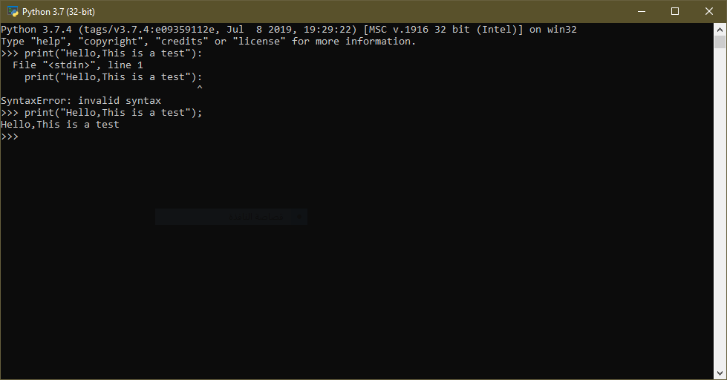

[1]B. Analytics and C. Codes), "Essentials of Machine Learning Algorithms (with Python and R Codes)", *Analytics Vidhya*, 2019. [Online]. Available: https://www.analyticsvidhya.com/blog/2017/09/common-machine-learning-algorithms/. [Accessed: 30- Jul- 2019].

[2]"A simple way to understand machine learning vs deep learning - Zendesk", *Zendesk*, 2019. [Online]. Available: https://www.zendesk.com/blog/machine-learning-and-deep-learning/. [Accessed: 30- Jul- 2019].

[3]B. Analytics and C. Codes), "Essentials of Machine Learning Algorithms (with Python and R Codes)", *Analytics Vidhya*, 2019. [Online]. Available: https://www.analyticsvidhya.com/blog/2017/09/common-machine-learning-algorithms/. [Accessed: 30- Jul- 2019].